Web Link: https://studio.code.org

Project Link: https://studio.code.org/projects/applab/ksyQnXJbCmJCjsvUaF2h3vngy1cJs3rXyAWrkdS1nOg?qr=true

**Invitation App**

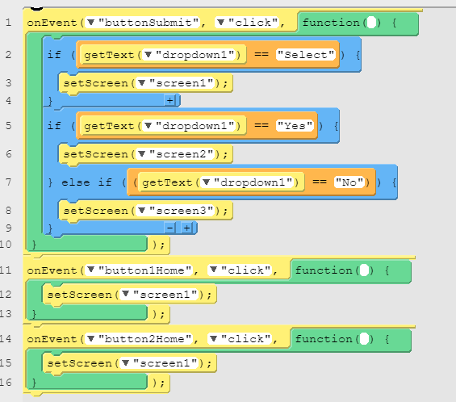

onEvent("buttonSubmit", "click", function( ) {

if (getText("dropdown1") == "Select") {

setScreen("screen1");

}

if (getText("dropdown1") == "Yes") {

setScreen("screen2");

} else if ((getText("dropdown1") == "No")) {

setScreen("screen3");

}

});

onEvent("button1Home", "click", function( ) {

setScreen("screen1");

});

onEvent("button2Home", "click", function( ) {

setScreen("screen1");

});